Zoe Kosmicki

Assignment 4

Task 4

I started by writing out fourth.s, and opening it in the gdb debugger after assembling and linking the program.

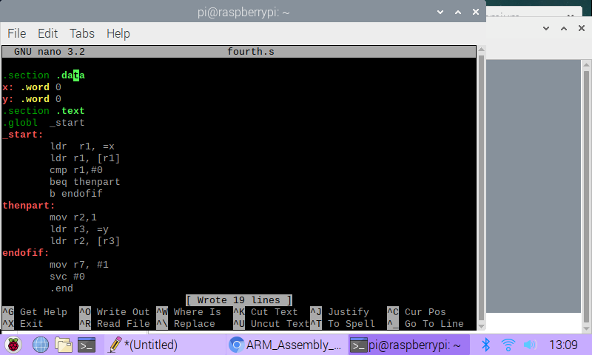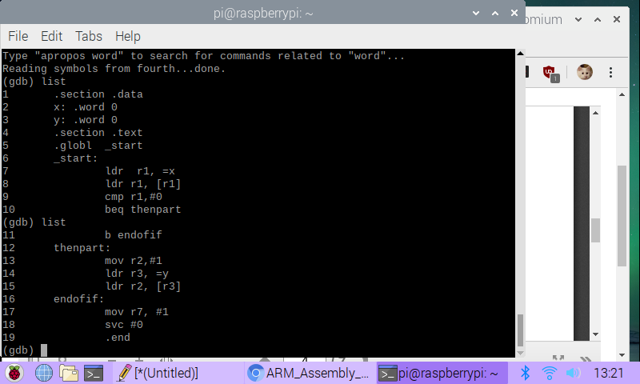I set a breakpoint at line 7, where the instructions started, and stepped through the whole program until I got to the end, at line 18. Then I used the info registers command to look at the CPSR as well as the register that held y. As can be seen below, the Z flag is set, and the memory location for y shows 0.

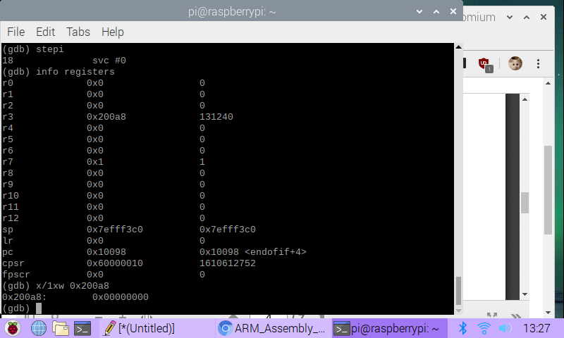Next, I updated fourth.s as instructed. Then I assembled, linked, and debugged it in the exact same way as I did the original fourth.s. Again, the Z flag is set.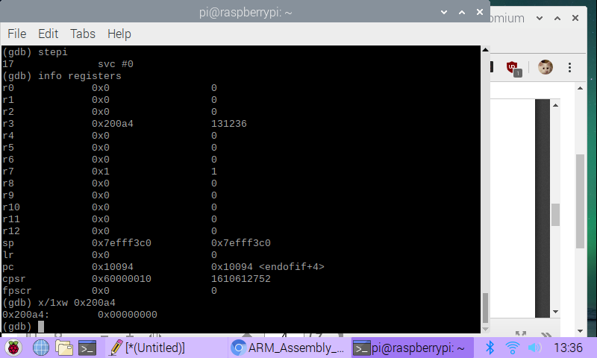

Next, I modified fourth.s to be ControlStructure1.s. I did this by adding another branch called greaterthan if x was greater than 3 that would execute x = x - 2.

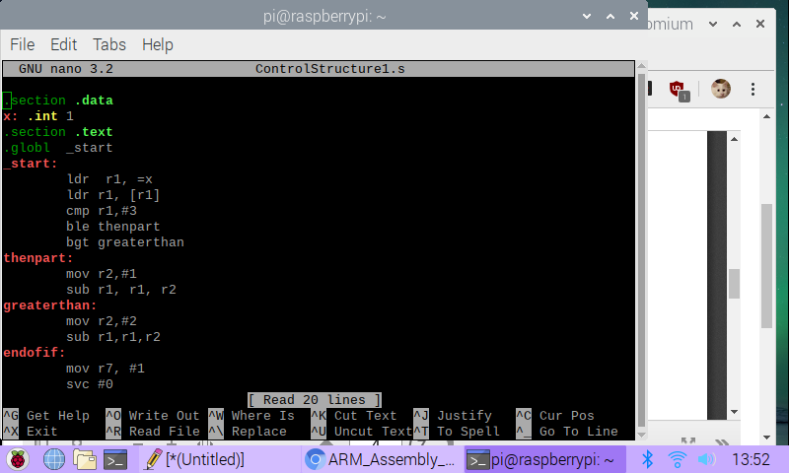I assembled, linked, and debugged it, and set breakpoints at lines 7 and 19. After stepping through the program once, I jumped to the end to examine the registers. Because x = 1, only the thenpart branch executed, leaving us with r1 as FFFFFFFE, which is -2. The Z flag is set.